|  |
| --- |
| ***Online shop 4 DVDs:*** |

|  |
| --- |
| *an amazing movies portal* |
|  |
|  |
|  |

# Certificate of Completion

This is to certify that

**MUHAMMAD BASIL**

**MAHAM SAJID**

**ANILA KAINAT**

**HAFIZ MUHAMMAD ANAS**

Has successfully completed I-project

Issue by ______________ Dated_______________

# Acknowledgement

We would like to acknowledge all those who have given us moral support and helped in making the project a success. We wish to express our gratitude to i-project Team at Head Office who guided and helped us. Also, we would like to express our gratitude to all the staff members of our center for not only providing us opportunity to work with them on this project, but also for their support and encouragement throughout the process.

We also express our sincere gratitude to I-project Team from Aptech Head Office and Our project guide at the organization for his valuable guidance and support for completion of this project.

Final, we would like to offer many thanks to all our colleagues for their valuable suggestions and constructive feedback.

# Preface

First of all, we would like to thank ALLAH the almighty, who gave us mind to think and heart to feel creativity & creation depends on thinking.

Many people contributed to this project, and I would like to thank all of them. Very special thanks to our teacher SIR ADIL KAMAL of APTECH for his advice and suggestion. He always encourage us to do the best. Indeed class fellows are very important and we would like to thank all of them for their appreciation and moral support.

We would also like to thankful to our parents whose well wishes allowed us to fulfill our dreams into reality.

Contents

* Certificate of Completion.
* Acknowledgement
* Preface
* Table of content
* Project briefing.
* Snap-shots
* Database design
* Diagram
* Customer Requirement Specification.
* Task sheet.

# Project Brief

**Problem statement**

The problem statement is attached separately in a file “OnlineShop4DVDs.doc”

**Standards plan:**

Every code block must have comments. The logic of the program needs to be explained. Proper documentation should be maintained. Complete Project Report along with synopsis, code and documentation should be prepared.

**Deliverables**

You need to submit the following Deliverables:

1. Hardbound Documentation of the project.
2. You need to follow all the following points as a part of your I-projects execution process and will carry **10 marks** in the final iProject Result.
3. Send us 2 (two) I-projects status mail, each should be after 10 days interval from your I-projects start date. Incase if your project is less than 30 days then also you need to send 2 (two) status mails (first status mail between 7-10 days and second 3 days before the end date of project).

b) The status mail should consist of description with review document (what's going on the project). Also you can send your doubts clarification or any additional inputs required to complete your I-project any time during the project planning and execution.

c) At the time of project submission also send us the feedback along with your documentation (soft and hard bound copy). The Feedback form is attached with this mail.

# snap-shots

Website Snap-shots:

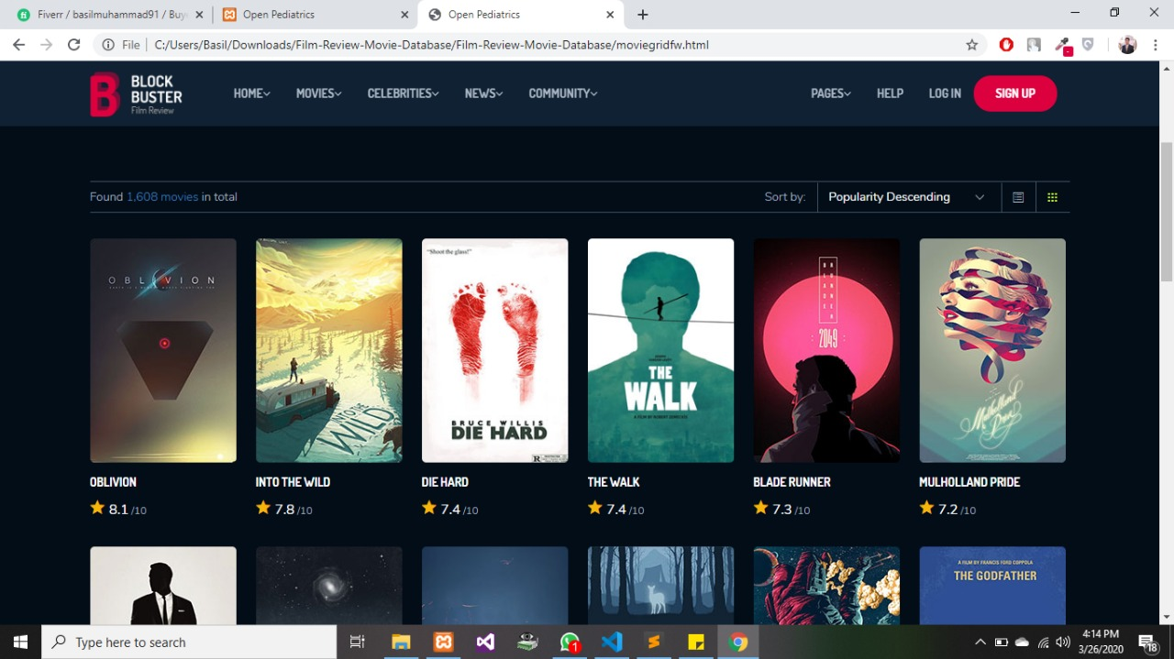

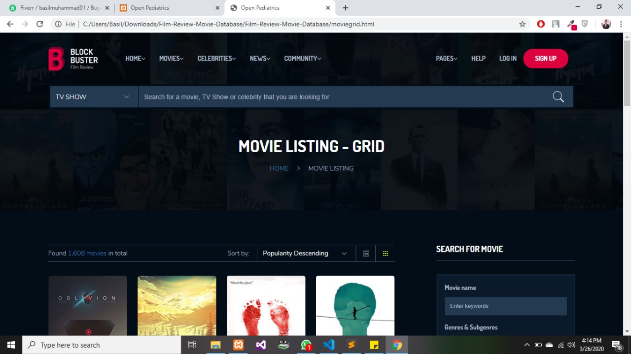

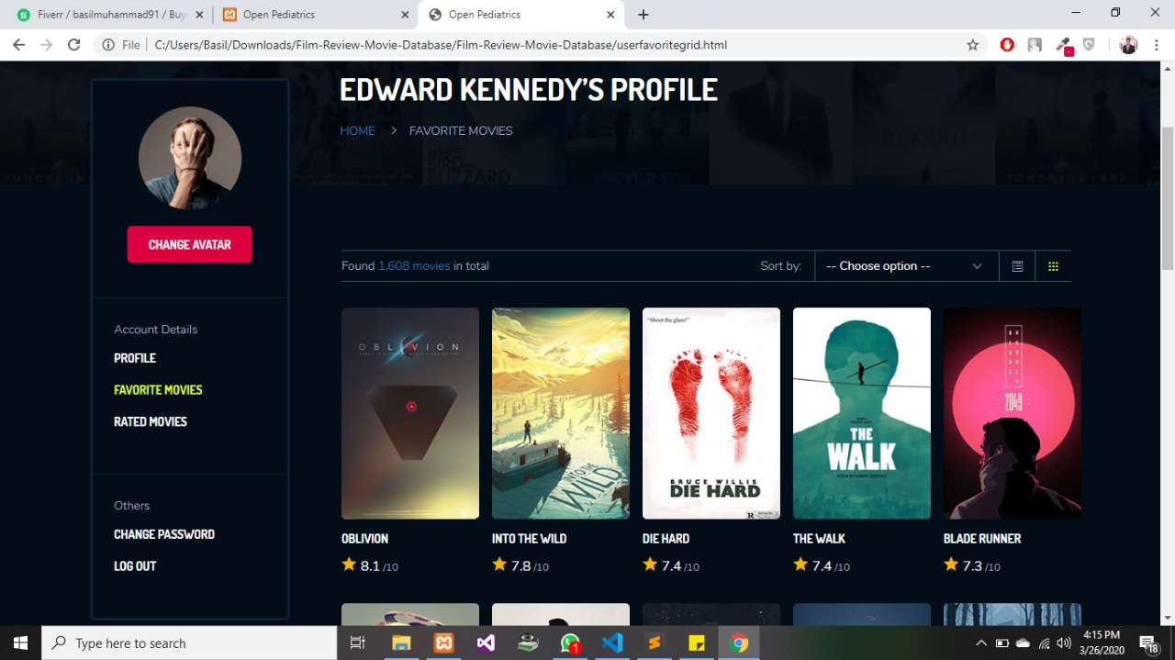

Dashboard:

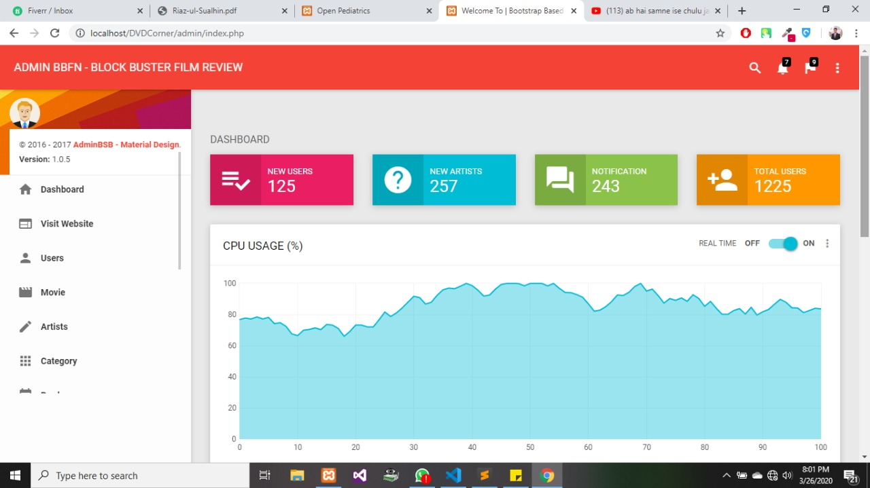

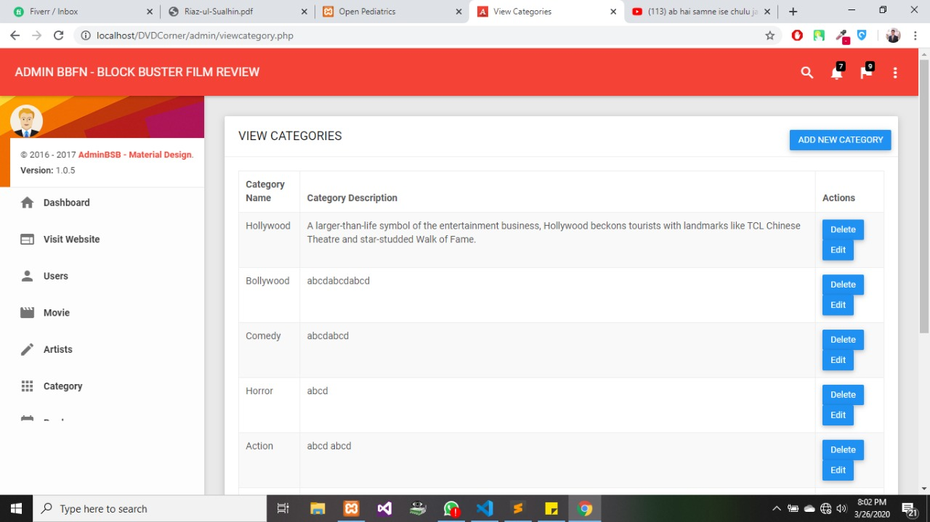

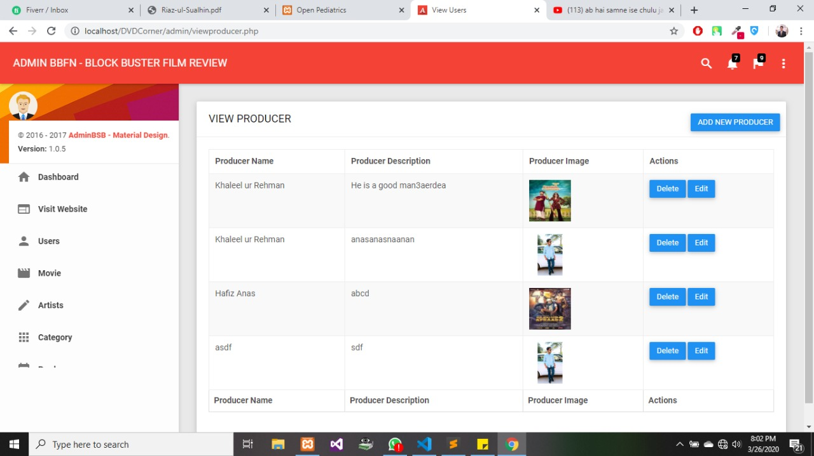

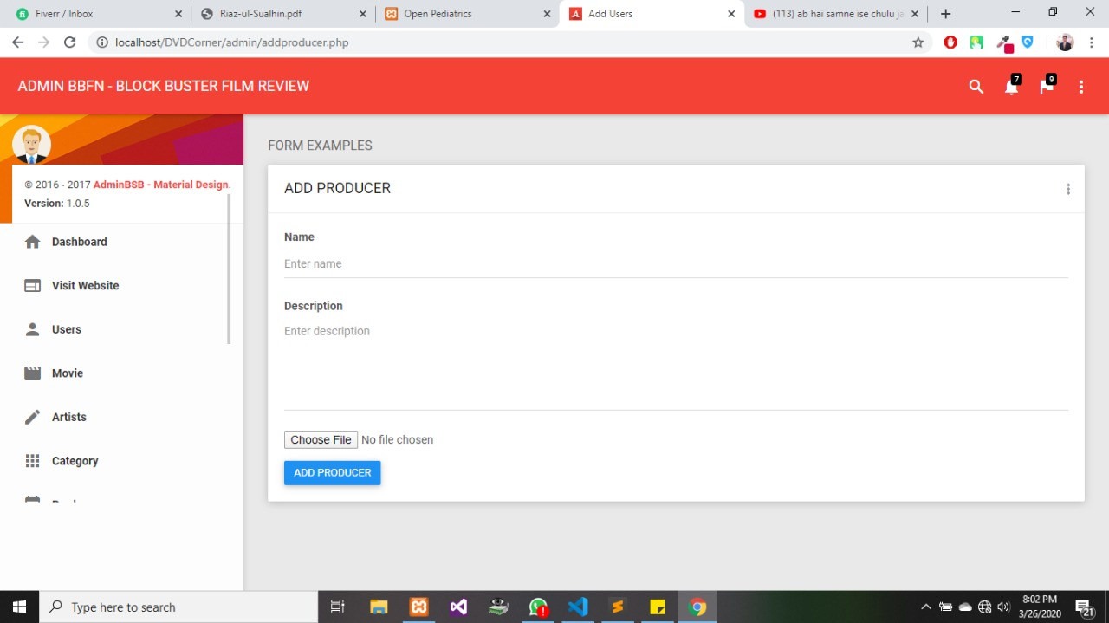

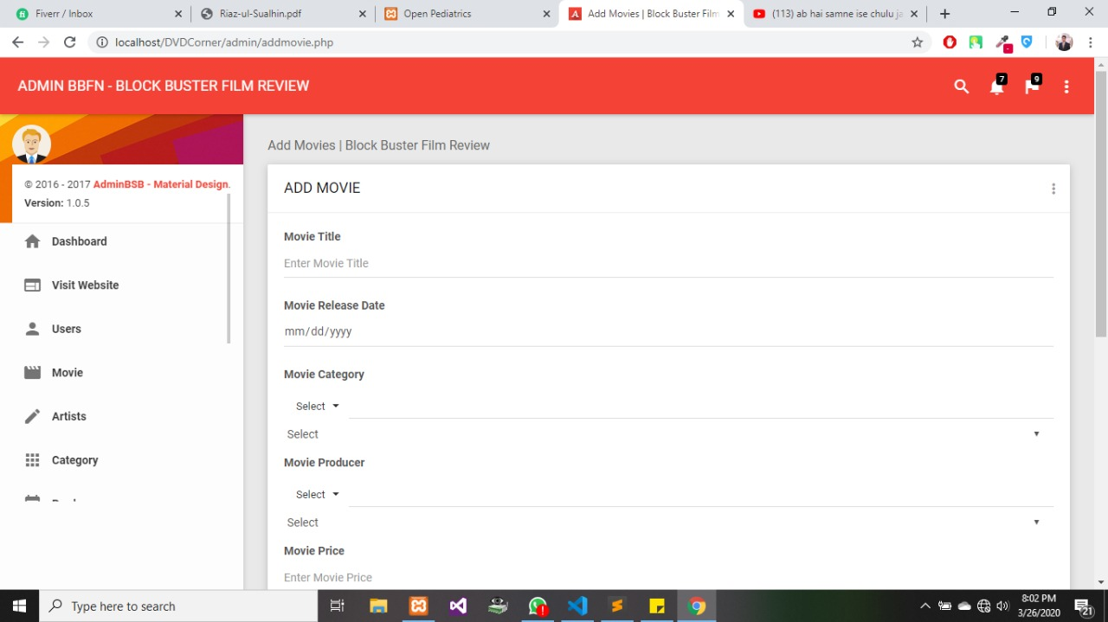

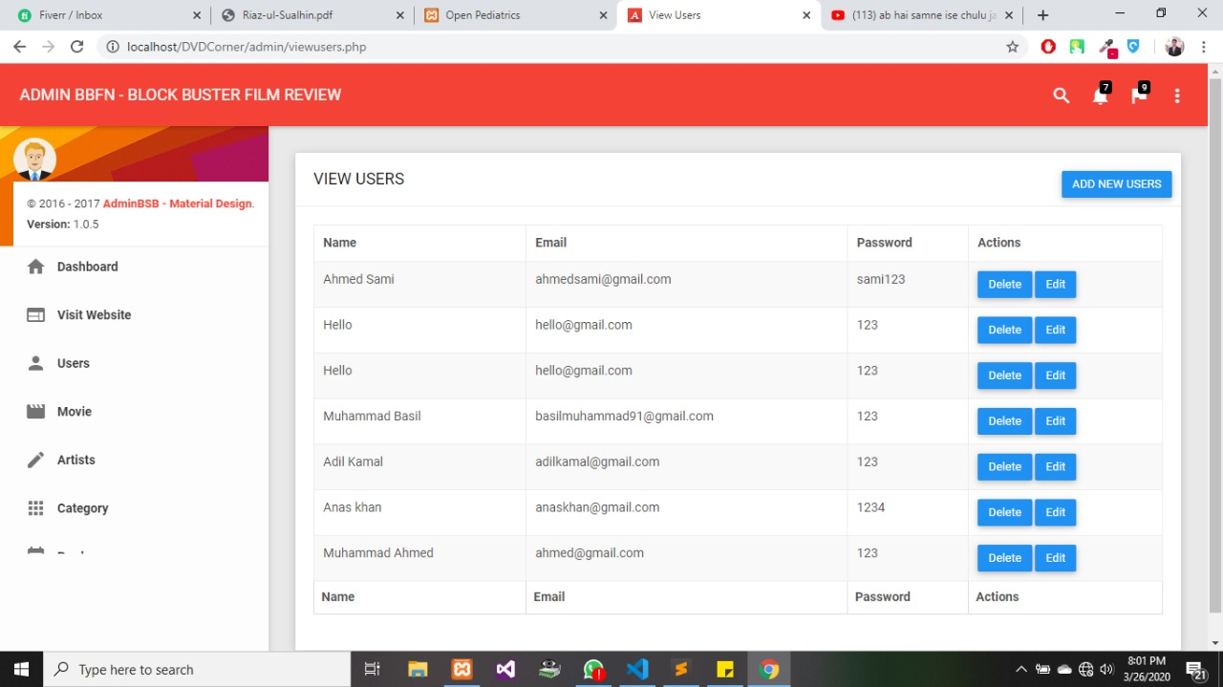

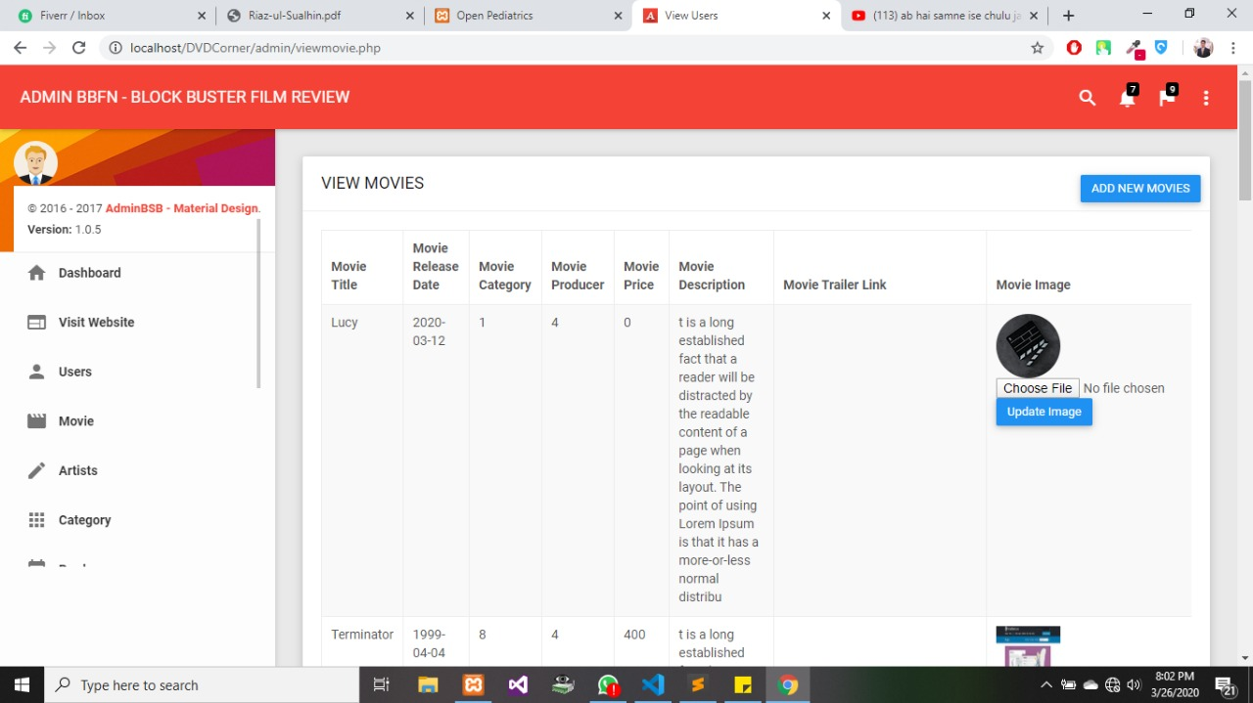



Sign up:

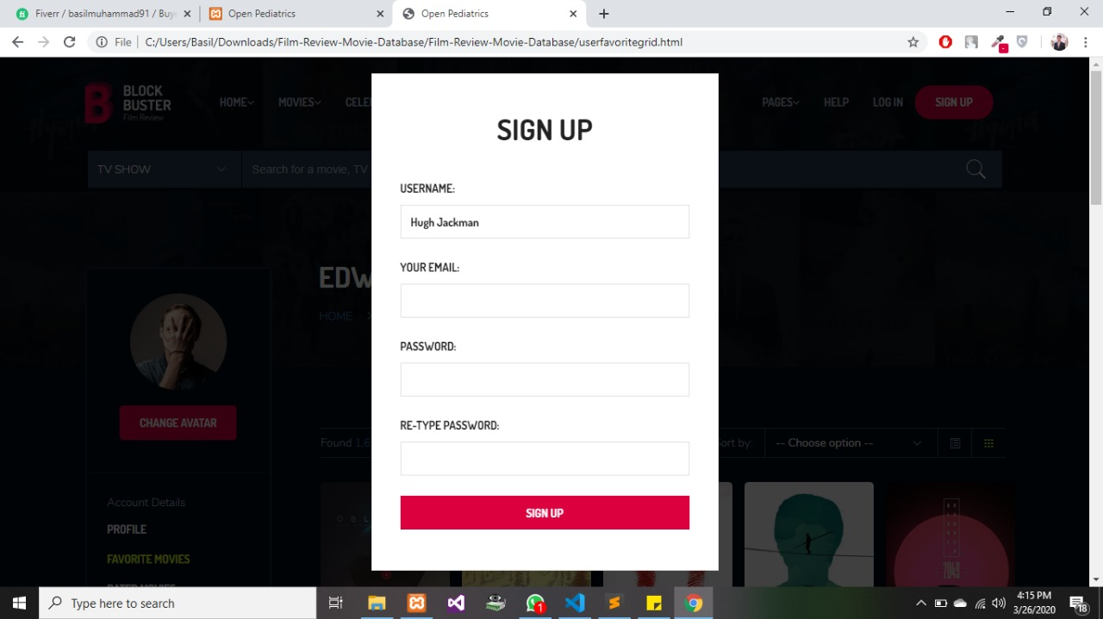

Log in:

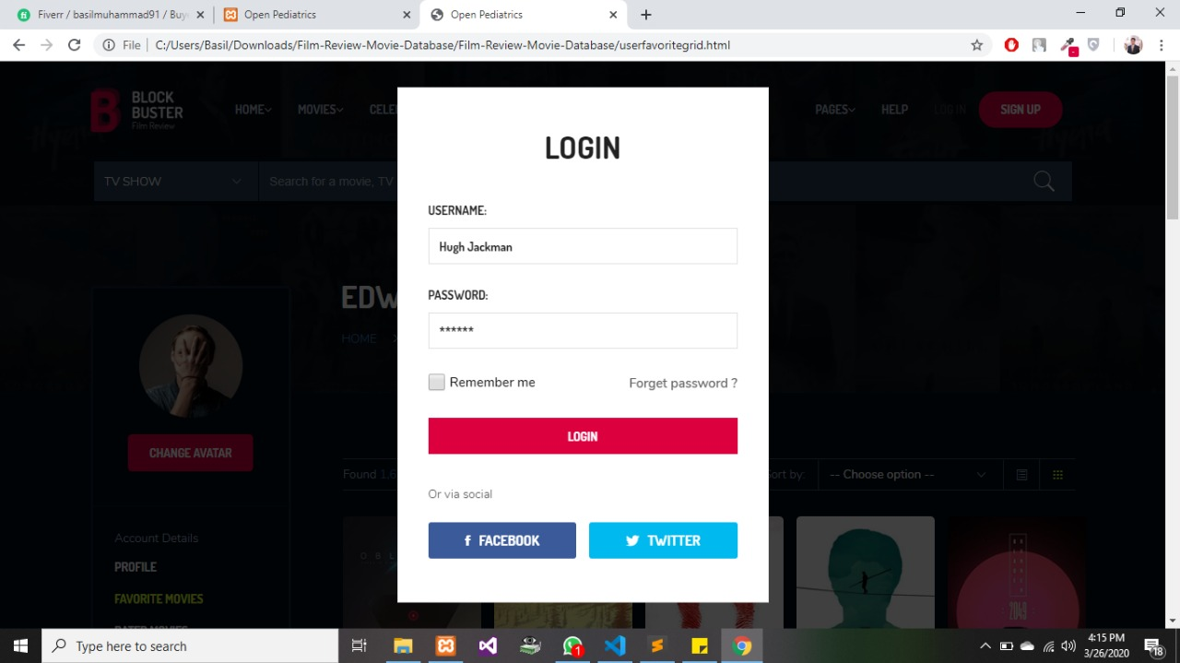

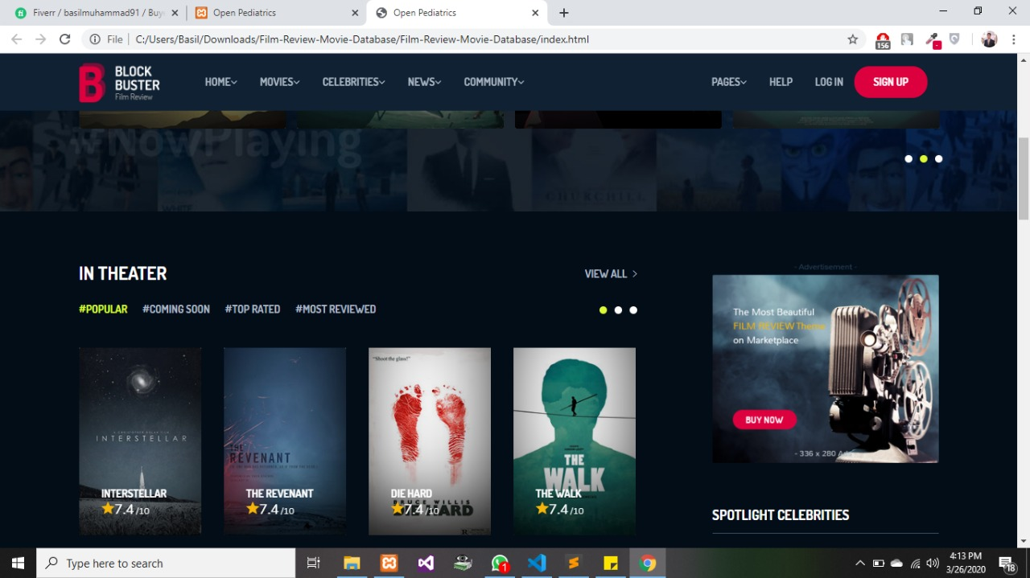

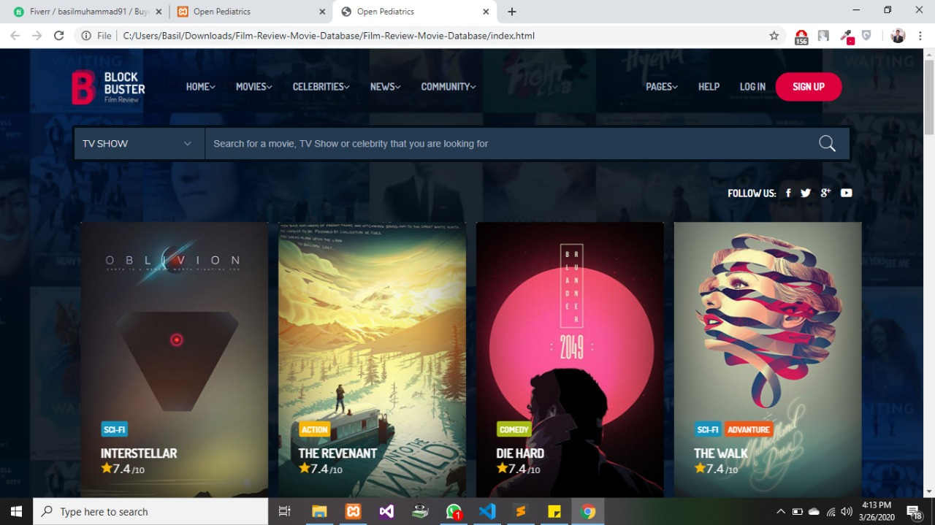

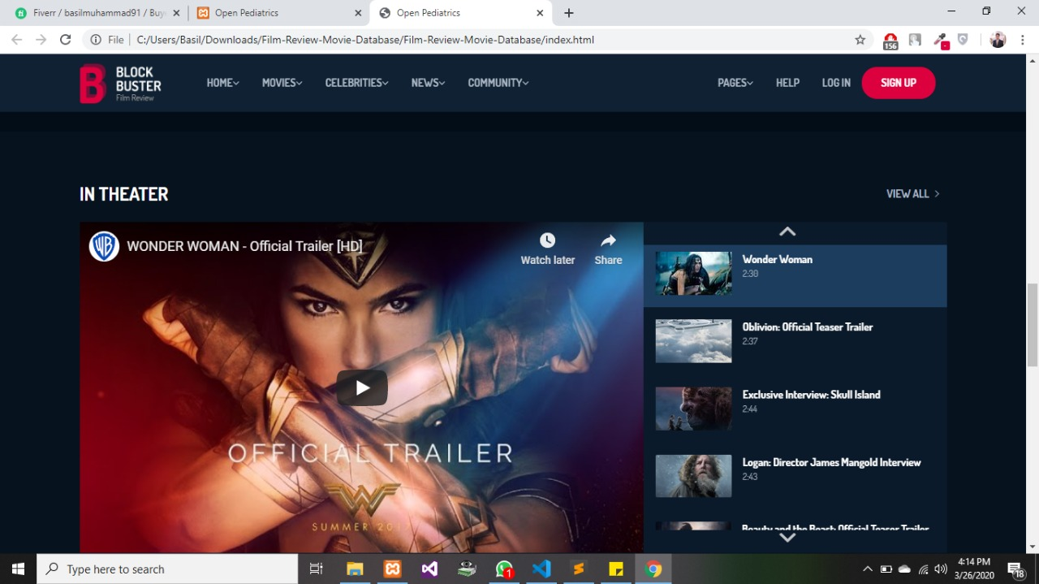

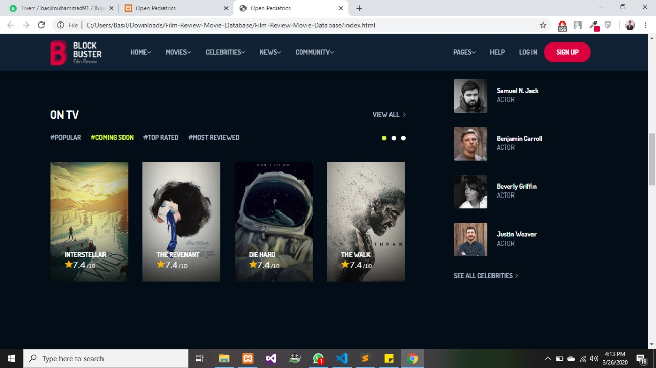

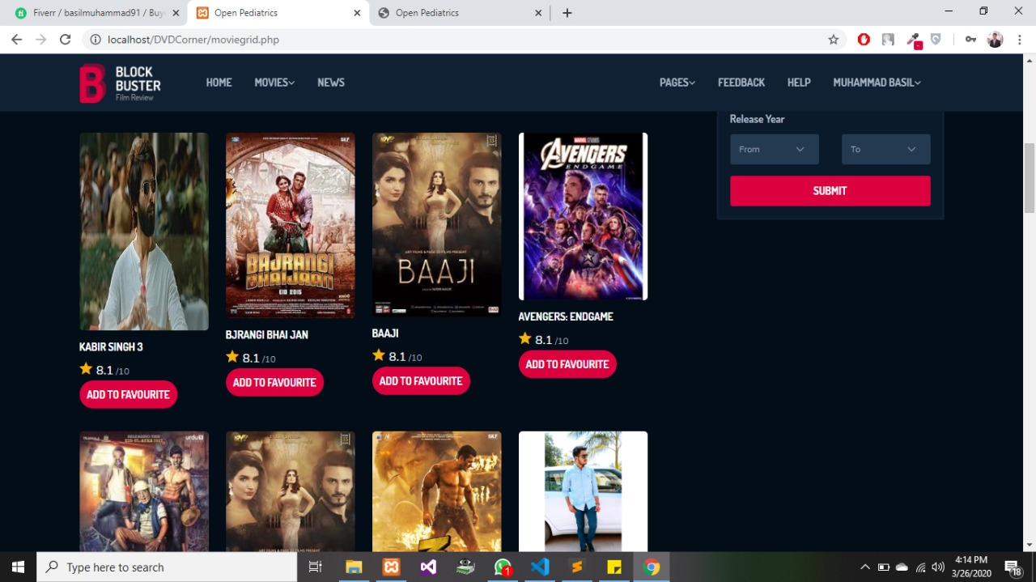

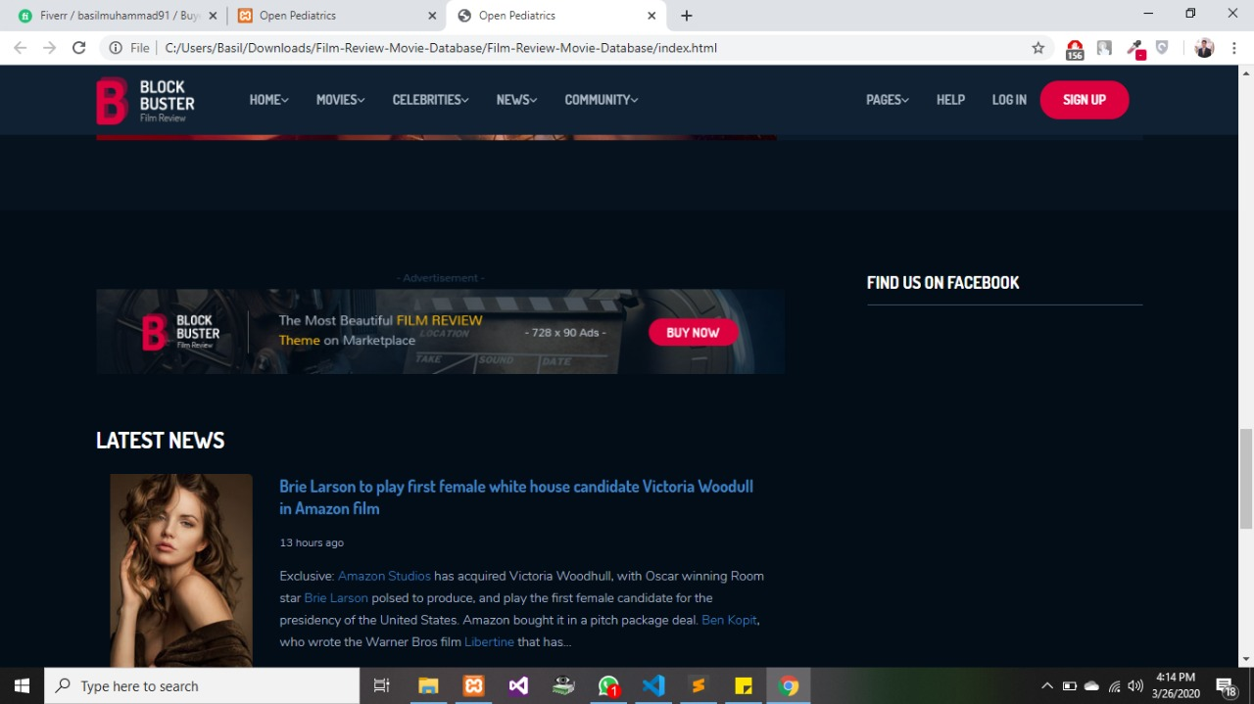

Dr-Diagram:

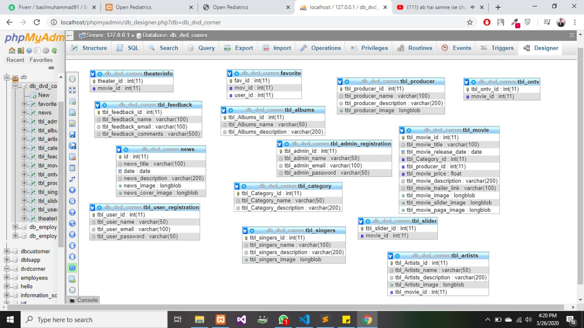

Database:

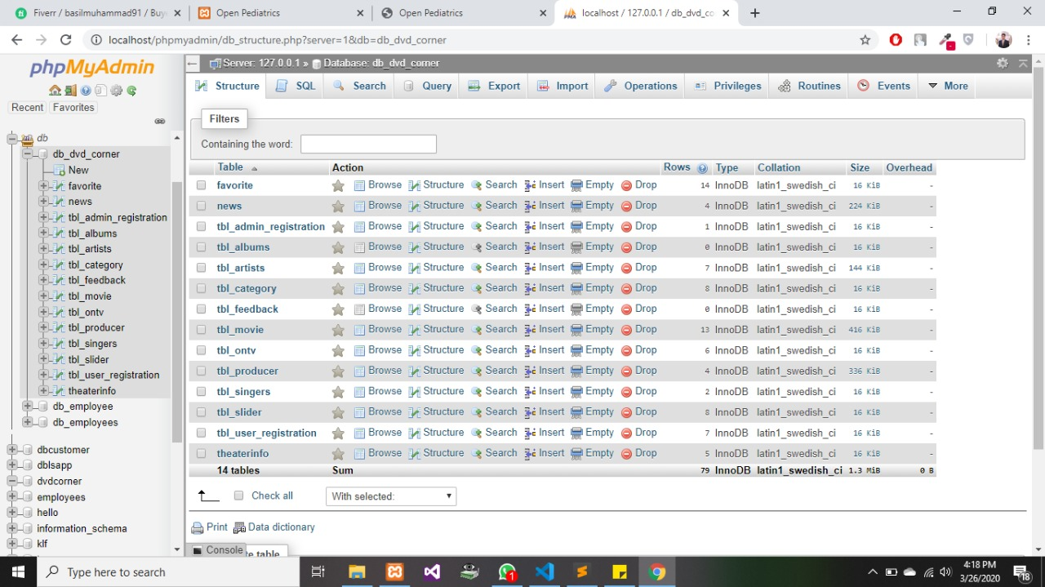

**Hardware & software requirements**

**Hardware:**

A minimum computer system that will help you access all the tools in the

Courses is a Pentium 166 or better

128 Megabytes of RAM or better

**Software:**

Visual Studio .Net / ASP

IIS server

.Net Framework

Java Virtual Machine/ J2EE server

Notepad/Java editor

j2sdk1.4.1_02 (or later).

EJB Dev Kit

Java enabled web server

JSP / Servlets Dev. Kit

Task Sheet:

Apart from the task laid out in the following chart, all the members have equally contributed for the project and worked equally on the project with full devotion.

|  |  |  |  |  |
| --- | --- | --- | --- | --- |
| ID # | Member Name | Member Role | Contribution | Days |
| Student1023506 | Muhammad Basil | Contributed All | 25% |  |
| Student1090195 | Maham Sajid | Contributed All | 25% |  |
| Student1089069 | Anila Kainat | Contributed All | 25% |  |
| Student1037357 | Hafiz Muhammad Anas | Contributed All | 25% |  |
|  |  |  | 100% |  |

**THANK YOU…**